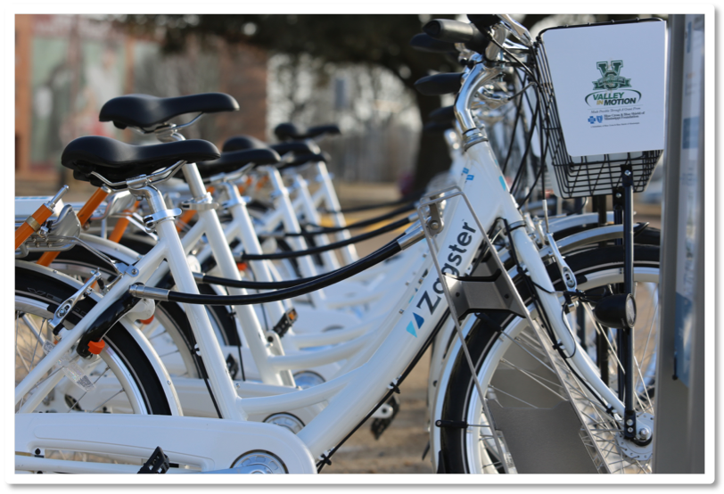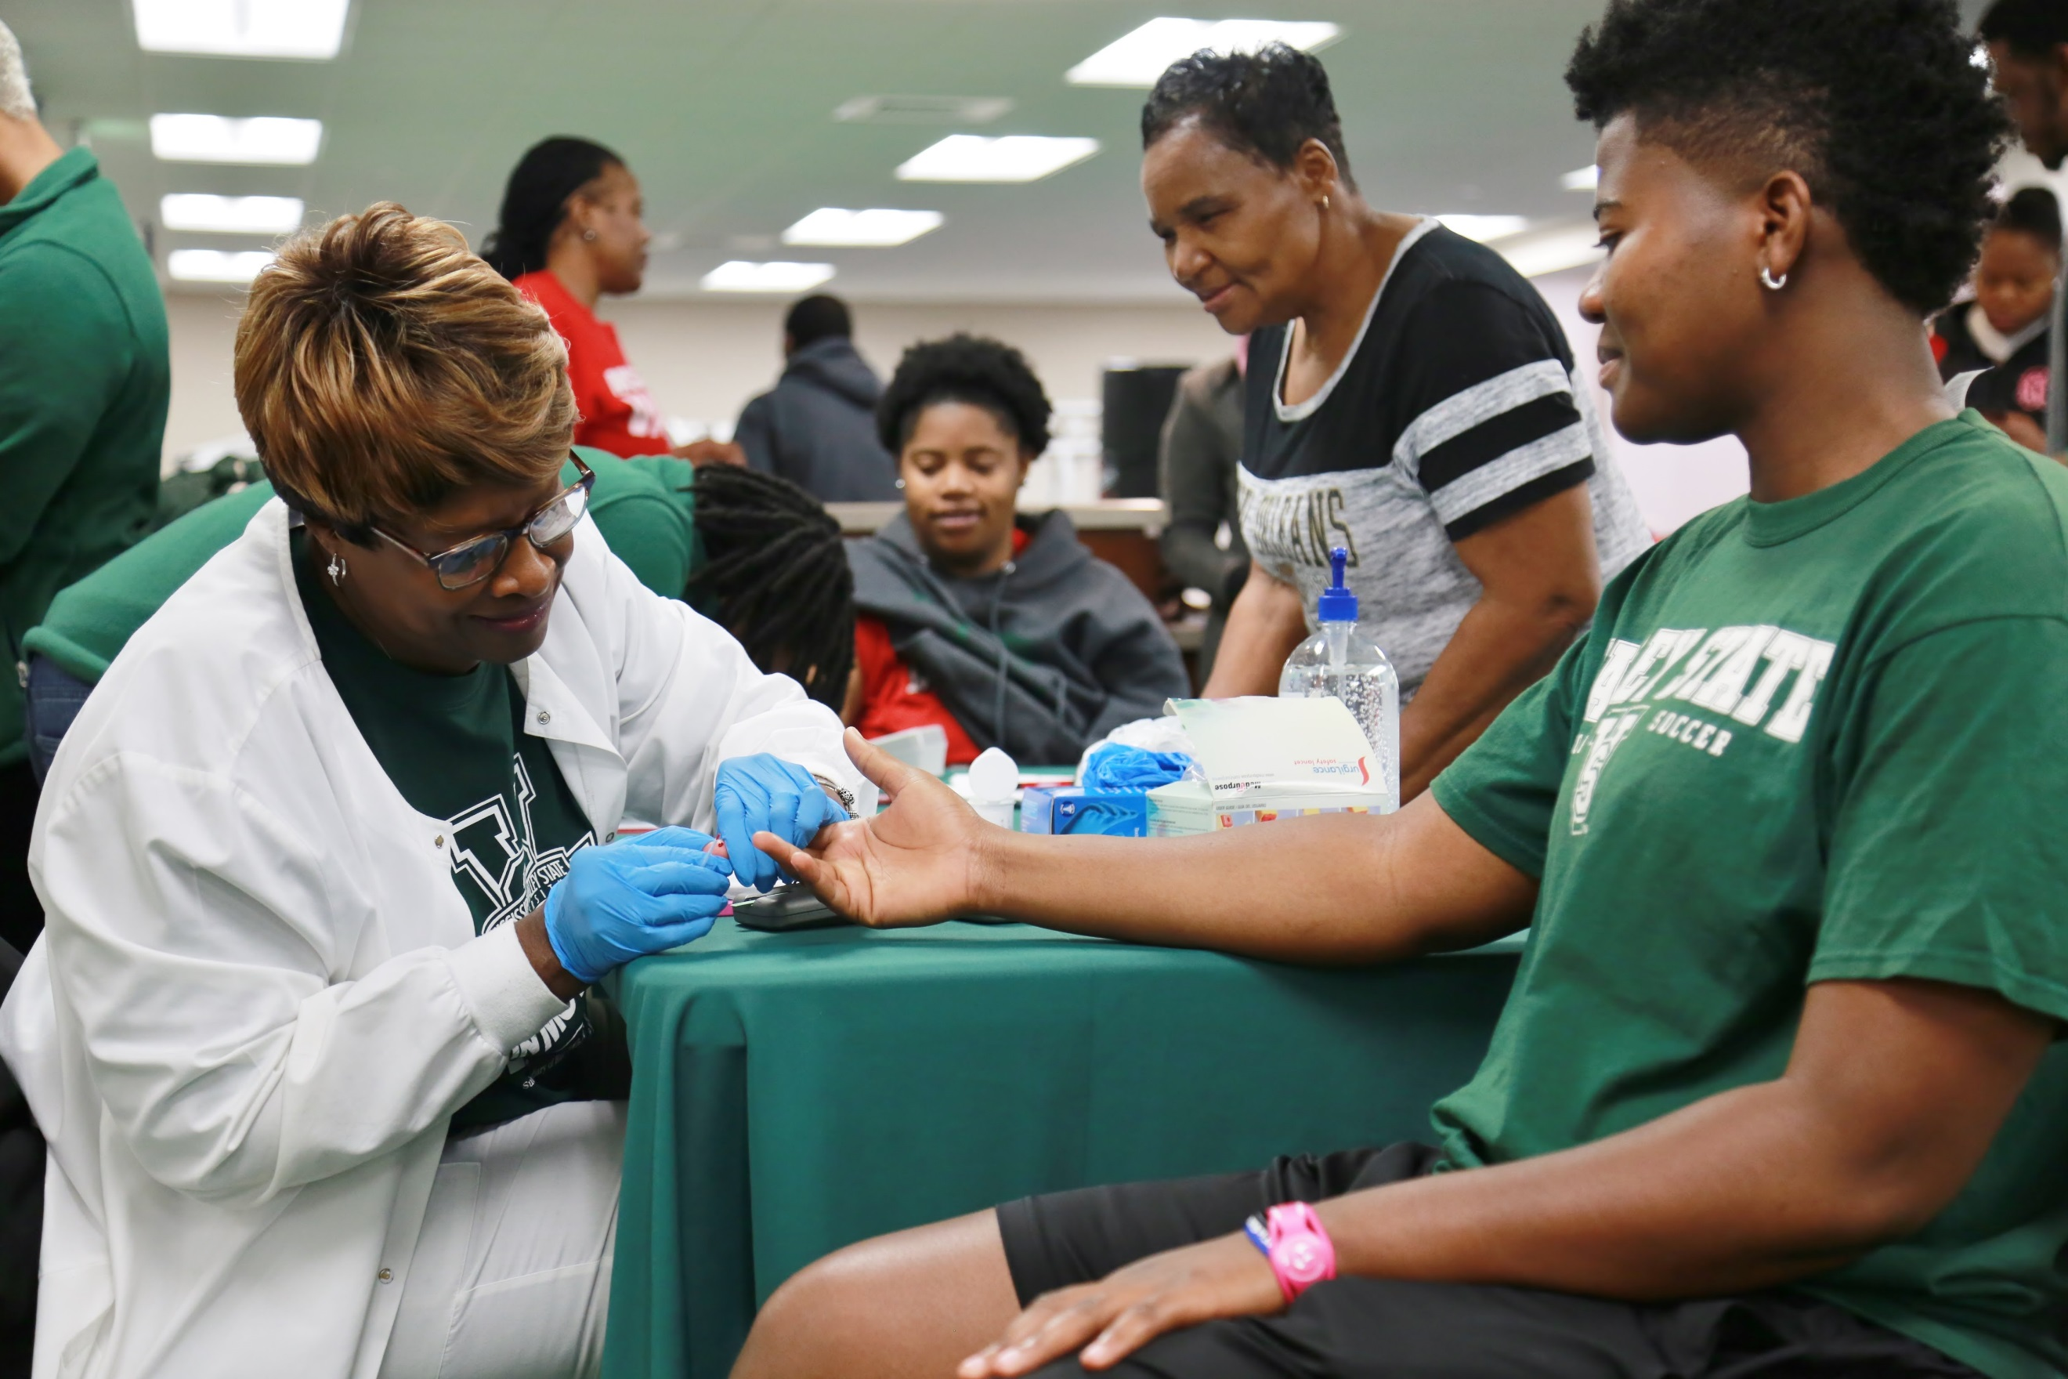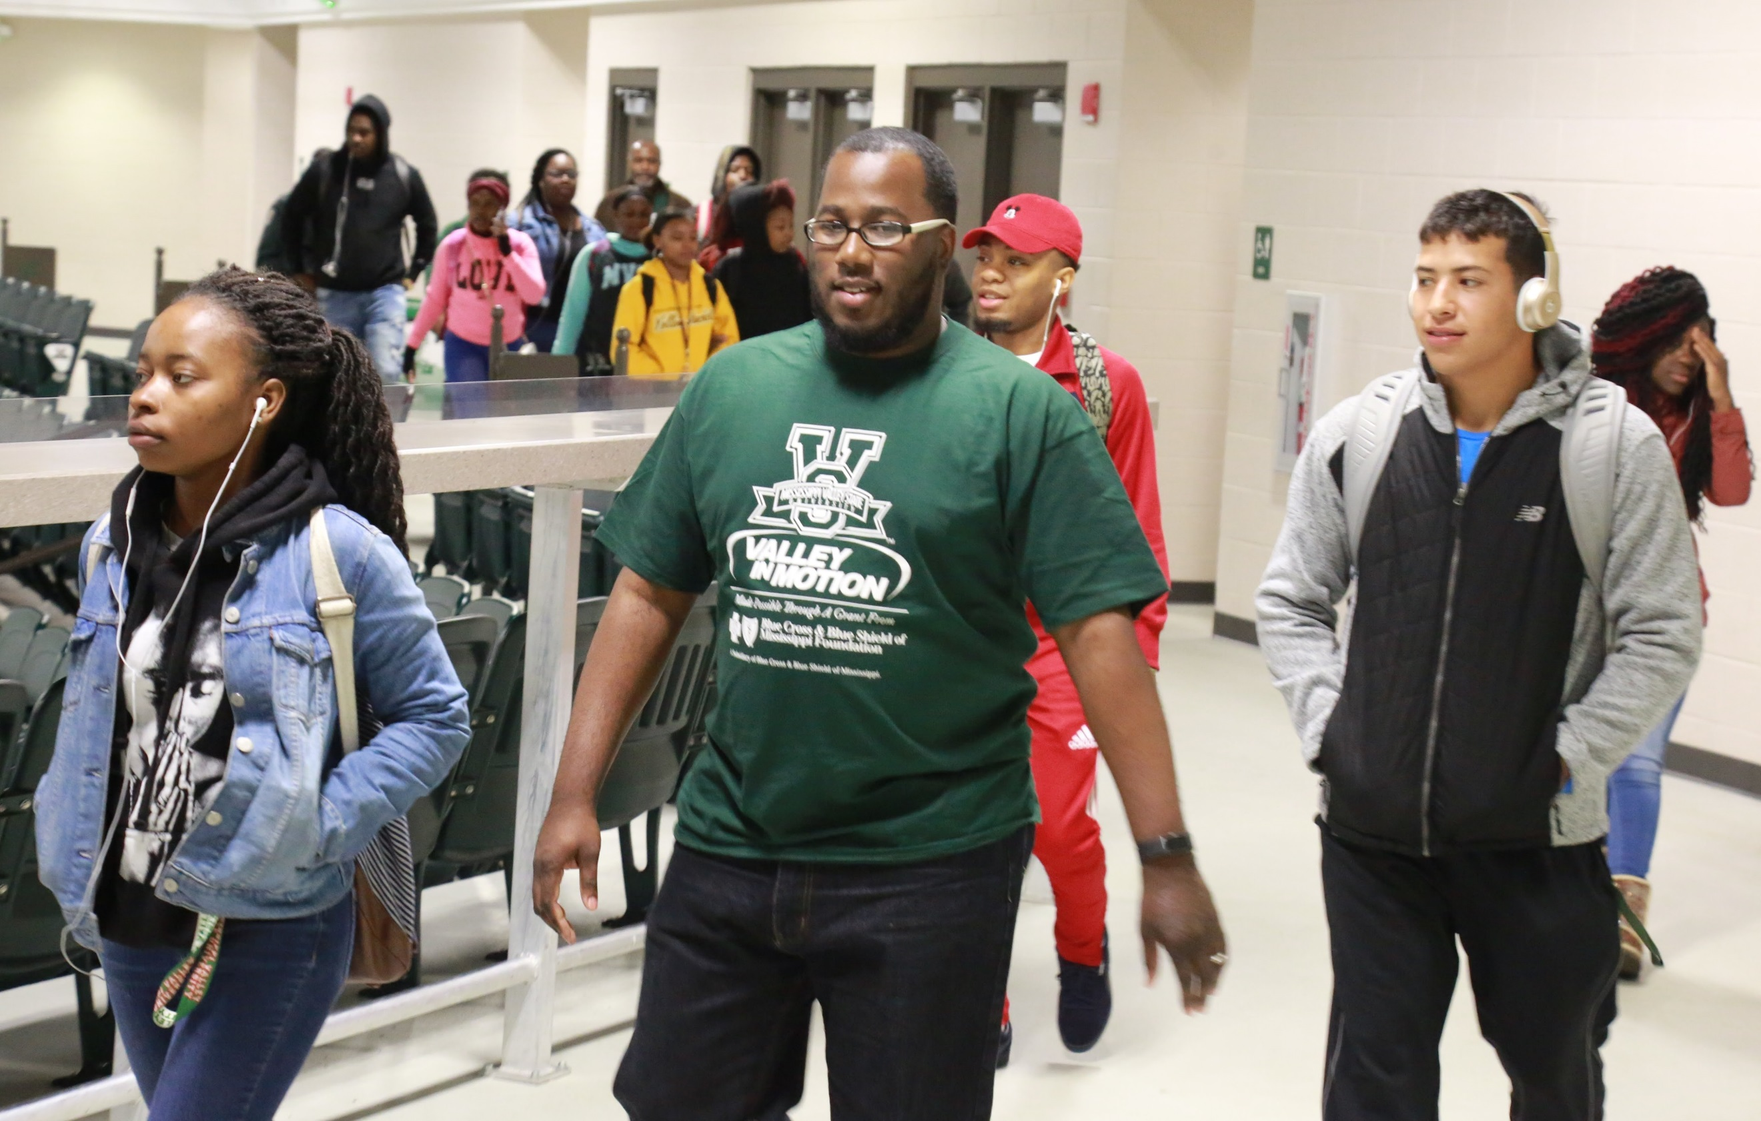

**TUESDAY**

**August 27, 2019**

**Cardio and Abs**

**5:00 a.m. - 10:00 a.m.**

**2:00 p.m. – 8:00 p.m.**

*Location: Wellness Center*

**THURSDAY**

**August 29, 2019**

**Cardio and Abs**

**5:00 a.m. - 10:00 a.m.**

**2:00 p.m. – 8:00 p.m.**

*Location: Wellness Center*

**MONDAY**

**August 26, 2019**

**Cardio and Abs**

**5:00 a.m. - 10:00 a.m.**

**2:00 p.m. – 8:00 p.m.**

*Location: Wellness Center*

**Bike Ride**

**4:00 p.m.**

*Location: MVSU Campus*

**FRIDAY**

**August 30, 2019**

**Cardio and Abs**

**5:00 a.m. - 10:00 a.m.**

**1:00 p.m. – 4:00 p.m.**

*Location: Wellness Center*

**WEDNESDAY**

**August 28, 2019**

**1K Walk Run**

**6:30 a.m. & 1:00 p.m.**

*Location: Harrison Complex (upstairs)*

**Cardio and Abs**

**5:00 a.m. - 10:00 a.m.**

**2:00 p.m. – 8:00 p.m.**

*Location: Wellness Center*

**Nurse Visit/Health Screening**

**10:00 a.m. - 1:00 p.m.**

*Location: Sutton Building, 3rd Floor, Office # 356*