OFFICE OF COMMUNITY SERVICE LEARNING
14000 HIGHWAY 82 WEST, BOX 7304, ITTA BENA, MS 38941
Phone: 662-254-3921/3922
OFFICE HOURS: MONDAY – FRIDAY 8 A.M. – 5 P.M.

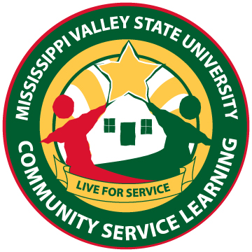
Community Service Partnership
Memorandum of Agreement

BETWEEN

Mississippi Valley State University
Office of Community Service Learning (CSL)
14000 Highway 82 West – Box 7304
Itta Bena, MS 38930

And (Organization’s name, address, authorized representative’s name and title)

“Partner Agency”

Mississippi Valley State University through the CSL is committed to fostering students’ community service and civic engagement. Towards this end, the collaborating Partner Agency hereby agrees to permit the CSL Office to place students enrolled at the university in its facility for a volunteered supervised community service learning experience subject to the following provisions:

- CSL’s Responsibilities

- CSL will explain to the Partner the purpose of the community service, the educational level of and types of performance expected from the students/volunteers.
- CSL will require participating volunteers/students to abide by the rules of dress and conduct and other reasonable regulations of the Partner and to exercise the highest degree of care with interacting with Partner clients and when using Partner’s supplies and equipment.
- CSL will meet with the designated Partner supervisor to discuss the specifics of the volunteer as it relates to the numbers of hours worked.
- Partner’s Responsibilities
- Partner will accept students for volunteer services placement. A schedule will be established between the individual student and the Partner in consultation with the CSL staff member.
- Partner will inform the CSL office of any problems directly related to the students’ performance and attitude.
- Partner agrees to not to displace any employee as a result of the placement of a student/volunteer at the worksite.
- Partner agrees to document through a time sheet the number of hours the student actually worked.

The parties, by and through their duly authorized representative, indicate their willingness to be bound by the foregoing provision by signing below:

Agency Name
________________________ _________________________
(Agency or Organization Name) Date

________________________ _________________________
(Agency contact person/Title - print) (Agency Representative Signature)

________________________________
Agency Contact Number

OFFICE USE ONLY

Community Service Learning (CSL)

__________________________________ __________________________________
(Community Service Learning Signature) Date

System: _______ ID: ____________ Recorded By: __________________________________________

Office of Community Service Learning
Gladys Flaggs, Coordinator Phone: 662-254-3921 e-mail: gflaggs@mvsu.edu
Stella Bell, Administrative Secretary Phone: 662-254-3922 e-mail: slbell@mvsu.edu
Revised: 1/14 sb

