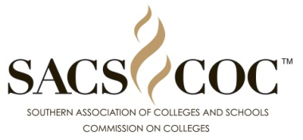

“Seal of accreditation”

DESIGN COMPETITION

The Executive Council of the Southern Association of Colleges and Schools Commission on Colleges (SACSCOC) has authorized a contest to develop a Seal of Accreditation to be used by member institutions to signify that they are accredited by SACSCOC. Faculty, staff and students are invited to send the Commission their ideas for a new seal.

The winning seal will become the property of SACSCOC and will be announced at the SACSCOC Annual Meeting in December 2017.

Prizes for the competition include:
- First prize: $500.00
- Second prize: $300.00
- Third prize: $200.00

Deadline for receiving entries:
- Friday, September 29, 2017.

Submission details:
- Entries should be submitted on paper and in electronic format. We are looking for a seal that presents well in both media.
- All submissions should be done as vector art and saved as an EPS file. Linked files should be embedded and all types/fonts outlined. A low resolution PDF file should also be sent for review.
- Entries should include the design with no identifying designer marks or affiliation.
- Designer identification should be included with the entry but should not be on the entry.
- Designer identification should include the designer’s name, mailing address, email address,
and telephone number. Designer identification should also include the name and address of the institution, as well as the affiliation of the designer (faculty, staff, student).
- All entries will be acknowledged upon receipt.
- All entries become the property of the Southern Association of Colleges and Schools Commission on Colleges.
- Entries will not be returned.
- Entries should be submitted to:

Seal Competition
SACSCOC
1866 Southern Lane
Decatur, GA 30033

Judging details:
- Identification will be removed from each entry.
- A team of Commission staff will screen the anonymous entries and select the top ten designs.
- The SACSCOC Board of Trustees will make the final selections from the anonymous entries.
- Winners will be announced at the December SACSCOC Annual Meeting, where the winning
seal will be presented.

Questions?
Contact Dr. Pamela Cravey, Coordinator of Communications and External Affairs at pcravey@sacscoc.org or (404) 994-6539.

